

Emergency Evacuation Plan
Free template from DDi OHS, version 4 November 2026. www.ddigroup.co.za/blog/emergency-evacuation-plan-template
Premises name | [ ]
Physical address | [ ]
Version | [ ]
Date issued | [ ]
Next review date (at least every 12 months) | [ ]
Prepared by | [ ]
Approved by (name, role, signature) | [ ]

Review this plan at least every 12 months, whenever the floor layout changes, and when a member of the emergency team leaves. Collect and destroy old copies when you issue a new version.

How to use this template
- Walk the building first and check every exit against your building plans.
- Fill in each section. Delete examples in grey that do not apply.
- Draw a floor plan for every floor (section 9) and put copies up at every exit and strategic point.
- Give the whole plan to every emergency team member. Keep the master copy somewhere safe that the team can reach.
- Train the team, run a drill, record it (section 10), and fix what the drill shows.
Check this plan against the OHS Act and your municipality's fire by-law.

1. Emergency telephone numbers
Service | Number
Fire and ambulance | 10177
From a cellphone | 112
Police | 10111
Local fire station | [ ]
Ambulance service | [ ]
Security company | [ ]
Building management or landlord | [ ]
Alarm company | [ ]
Electricity faults | [ ]
Gas supplier | [ ]
Incident commander (cell) | [ ]

Put this list next to every telephone.

2. General information
Physical address and GPS coordinates | [ ]
What happens on the premises (activities, processes, hazardous materials stored) | [ ]
Number of people present: day shift, night shift, weekends, typical visitors per day | [ ]
Control room: yes / no, where | [ ]
Alarm system: type, where the panel is, backup method [for example an air horn] | [ ]

Emergency contacts
Name | Role | Cell | Alternative

3. Area study

Emergency incidents on the premises
Date | What happened | What was done

Important features and landmarks (access roads, fire hydrants, gates, where the fire brigade enters) | [ ]

Adjacent premises
Name | Activity | Hazards that could affect us | Contact

4. Threats and their impact
Threat | Likelihood (low / medium / high) | Impact on the premises | Action plan (section 8)
Fire
Bomb threat
Gas leak
Chemical spill
Armed robbery or intruders
Civil unrest
Flooding
Power failure (dark stairwells, electric gates and magnetic doors)
Medical emergency
Structural collapse
Other [ ]

5. Emergency equipment
Equipment | Location | Number | Last serviced | Next service
Fire extinguishers
Fire hose reels
Alarm call points
First aid kits
Emergency lighting
Two-way radios
Air horn or whistle
Evacuation chair
Defibrillator (AED)
Other [ ]

6. The emergency team
Role | Name | Deputy | Cell | Trained on (course and date) | Appointed in writing (date)
Incident commander
Deputy incident commander
Floor warden: Ground floor
Floor warden: 1st floor
Floor warden: 2nd floor
Floor warden: [add rows]
Fire fighters
First aiders
Security
Continuity officer

Appoint every role in writing. We recommend at least one warden per floor, more on large floors.

Who reports to whom
Fire brigade and management (briefed by the incident commander)
Incident commander: [name]
Report to the incident commander: floor wardens [names], fire fighters [names], first aiders [names]

7. Duties of the emergency team
Pre-filled: change them to suit your premises.
Incident commander: takes charge, receives floor reports and the roll call, decides when it is safe to go back in, briefs the fire brigade.
Floor wardens: clear their floor (toilets, storerooms, meeting rooms), guide people to the exits, report the floor clear to the incident commander.
Fire fighters: deal with a small fire only if it is safe, then evacuate.
First aiders: look after anyone injured or unwell at the assembly point.
Security: hold the visitor and contractor list, help clear floors, keep the entrance clear for the fire brigade and meet it.
Continuity officer: protects critical records and systems and plans the return to work.

8. Action plans and emergency procedures

Fire
- Raise the alarm at the nearest call point.
- Call the fire brigade.
- Only use an extinguisher if it is safe and you are trained.
- Leave by the nearest exit. Walk, do not use the lift, leave your belongings.
- Go to the assembly point for the roll call.
- Do not go back in until the incident commander says it is safe.

Bomb threat
[Use the questionnaire in section 11.]
Steps | [ ]

Gas leak
Steps | [ ]

Medical emergency
Steps | [ ]

Power failure
Steps | [ ]

Civil unrest or armed intruders
Steps | [ ]

Flooding
Steps | [ ]

Assembly point and roll call
Assembly point location | [ ]
Alternative assembly point | [ ]
Who does the roll call | [ ]
How visitors and contractors are counted | [ ]

In a multi-tenant building, use one assembly area with a separate line for each company.

People who need help to get out
Write one personal evacuation plan for each person who needs help to get out (form in the annex).

9. Floor plans and maps

Each floor plan must show:
☐ a "you are here" marker
☐ escape routes as arrows matching the signs on the walls
☐ exits and stairs
☐ the assembly point
☐ fire extinguishers, hose reels, alarm call points and first aid kits
☐ a key
☐ what to do in a fire
☐ the date and next review date
Use the safety signs in SANS 1186 (they match ISO 7010) and follow SANS 23601 for the plan layout.

Example
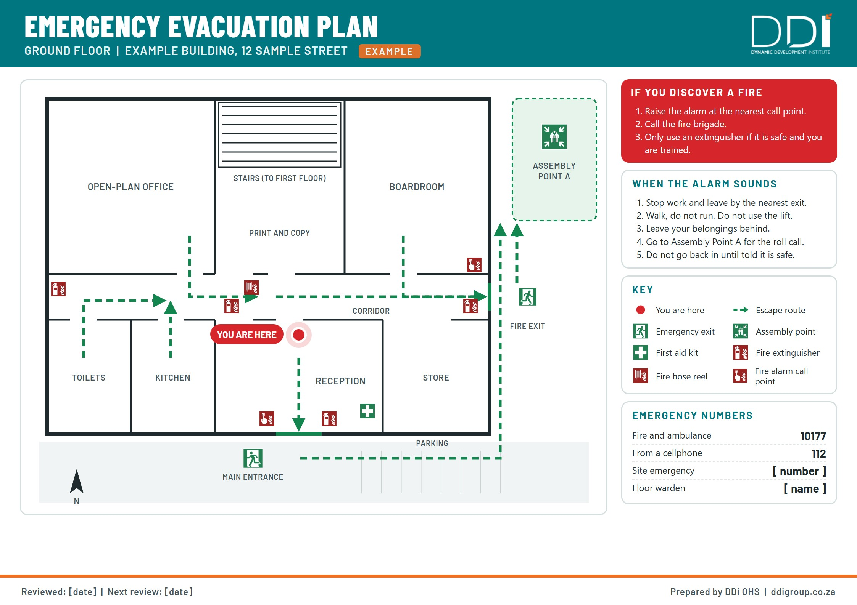

Your floor plan: [floor]. Draw on a printout, or paste your own drawing over this sheet.
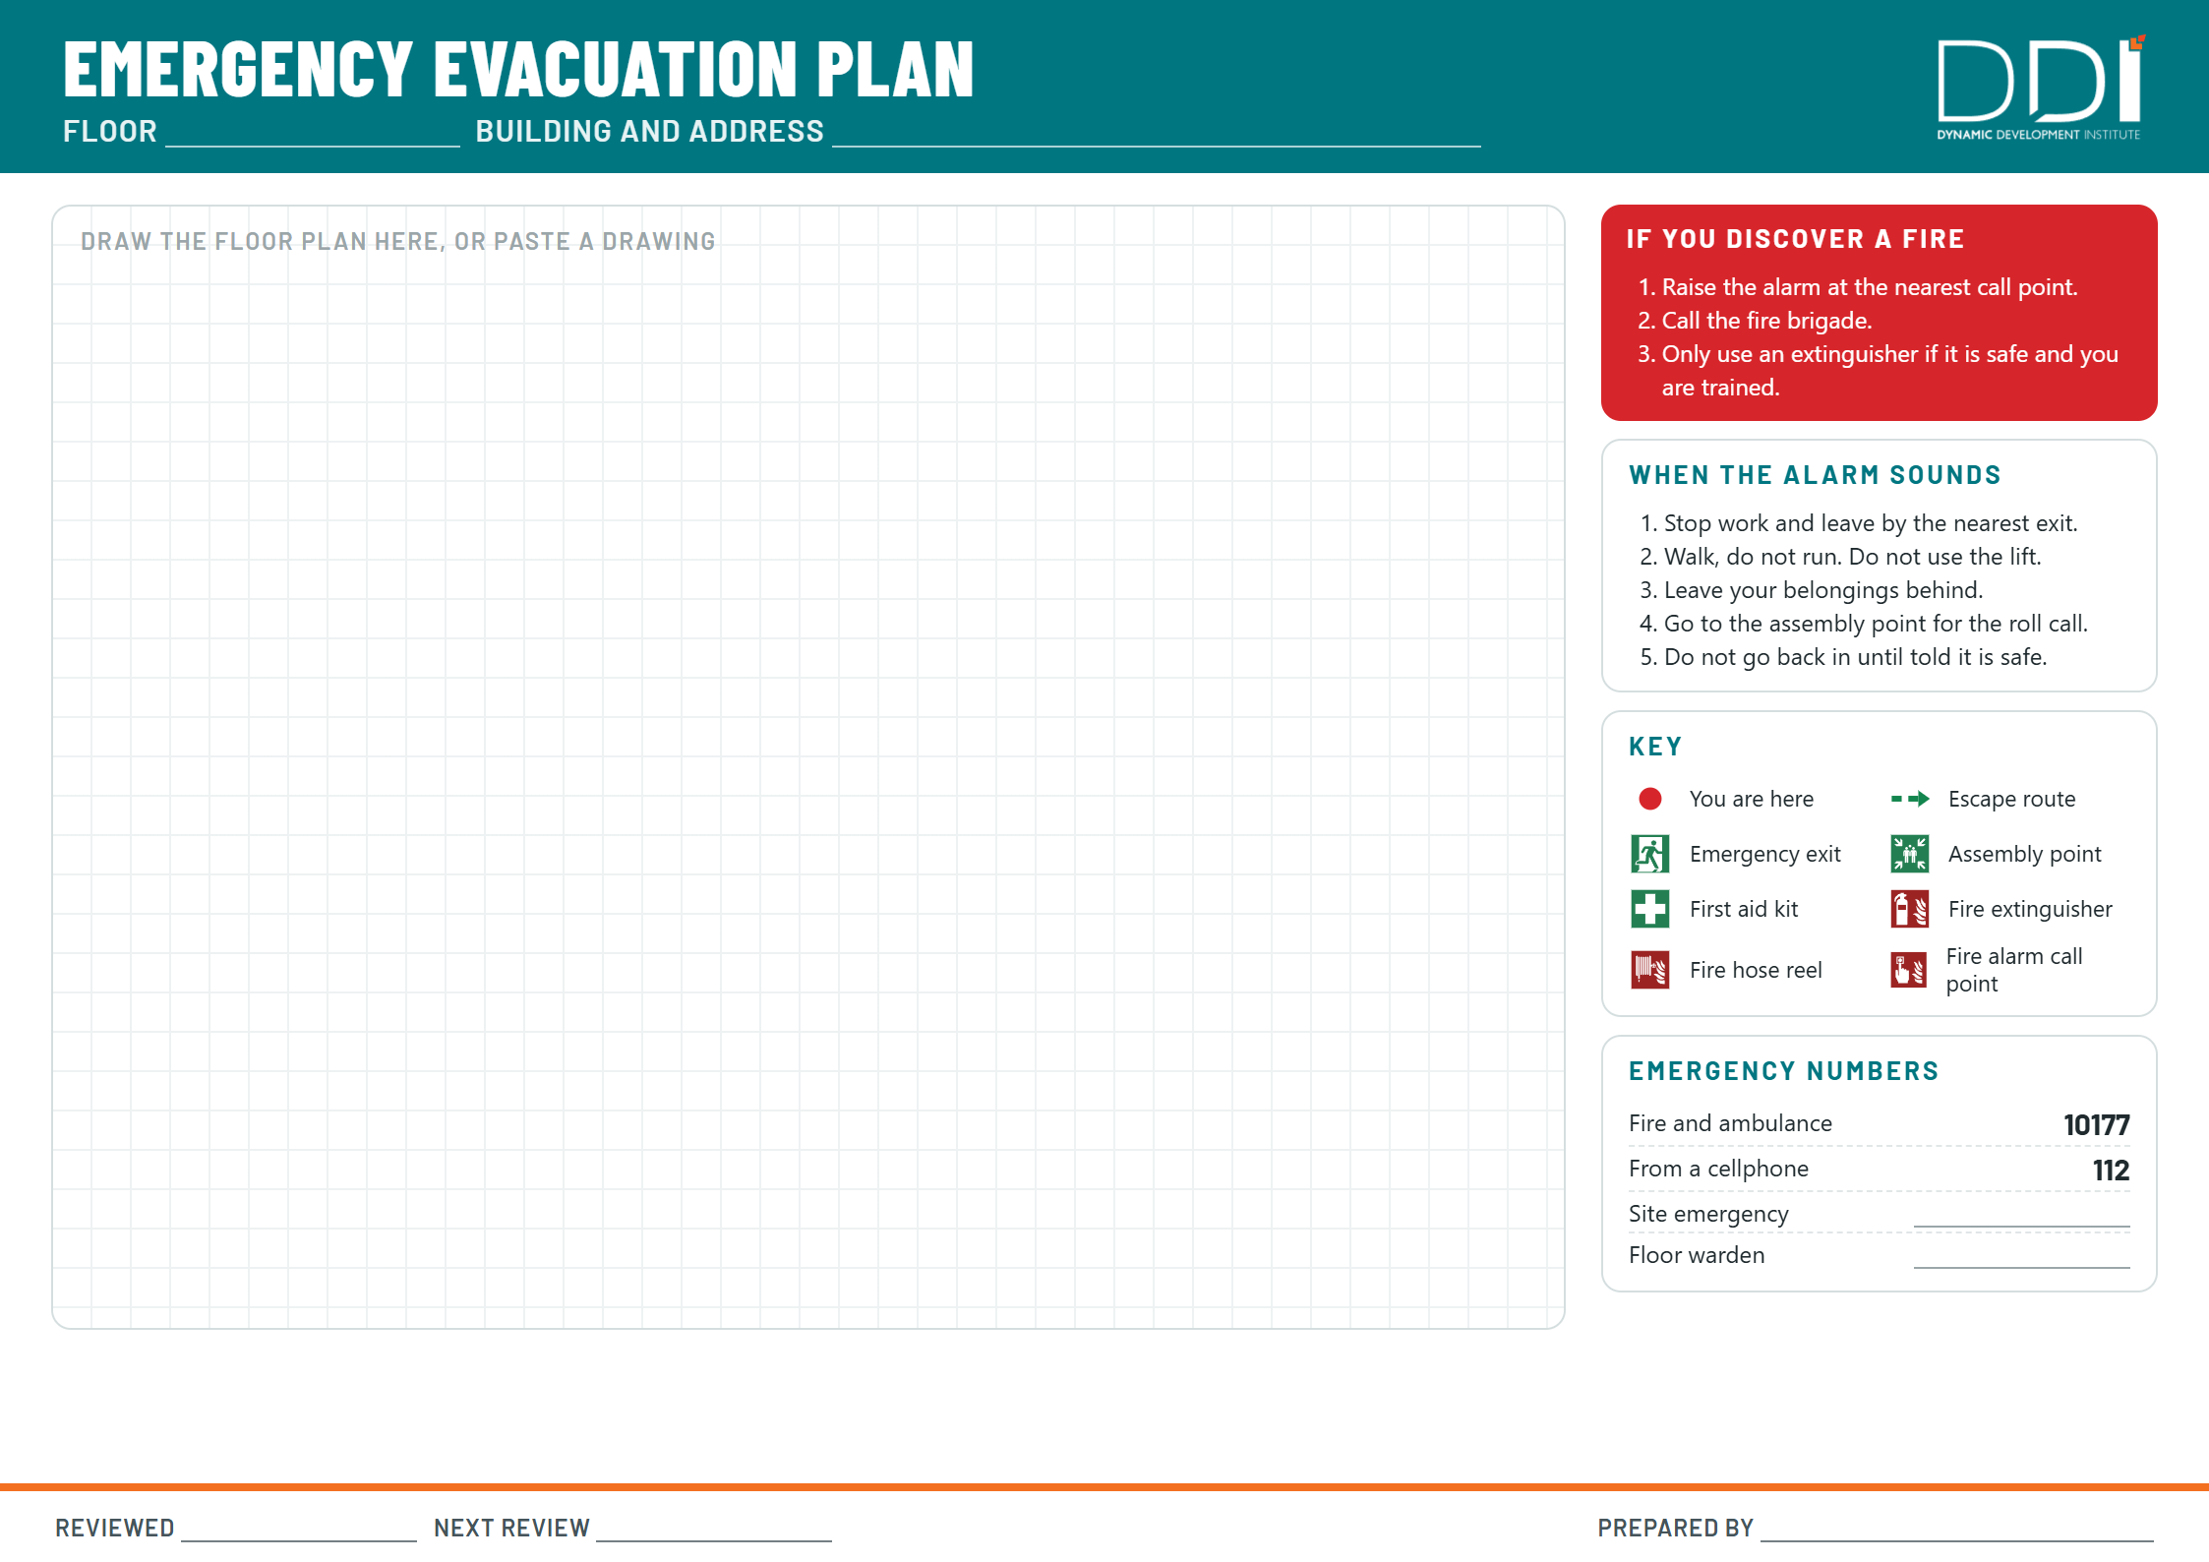

Site map or relevant topographical map [paste or draw here] | [ ]

10. Registers

Plan register
Version | Date | What changed | Changed by | Approved by

Training register
Name | Role | Course | Date trained | Certificate expiry

Drill register
Date and time | Planned or unplanned | Participants (staff, visitors, others) | Evacuation time | Roll call result | Outcome | Problems found | Corrective action | Responsible person | Due date | Supervisor name and signature

11. Bomb threat questionnaire
One page. Keep a copy at every telephone.
Stay calm. Keep the caller talking. Write down their exact words. Do not hang up first.

Questions to ask
When is the bomb going to explode? | [ ]
Where is it right now? | [ ]
What does it look like? | [ ]
What kind of bomb is it? | [ ]
What will make it explode? | [ ]
Did you place the bomb? | [ ]
Why? | [ ]
What is your name? | [ ]
Where are you calling from? | [ ]

Record
Date and time of the call | [ ]
Number displayed | [ ]
Exact words of the threat | [ ]
Caller: male / female, approximate age, accent or language | [ ]
Voice: calm / angry / excited / slow / rapid / slurred / disguised | [ ]
Background noises: traffic / voices / music / machinery / quiet | [ ]
Was the voice familiar? | [ ]
Call ended at | [ ]
Your name | [ ]
Who you reported it to and when | [ ]

Report it to the incident commander and the police (10111) immediately. Do not touch any suspicious object.

Annex: Personal evacuation plan
One page per person.
Name | [ ]
Department | [ ]
Usual location (floor and room) | [ ]
Help needed [for example: cannot use stairs, visual impairment, hearing impairment, temporary injury, pregnancy] | [ ]
How they will be alerted to the alarm [for example: a buddy, visual alarm, phone message] | [ ]
Buddy 1 (name, cell) | [ ]
Buddy 2 (name, cell) | [ ]
Route out, and safe waiting area if the stairs cannot be used | [ ]
Equipment needed [for example: an evacuation chair] | [ ]
Copy given to security: yes / no | [ ]
Practised in a drill on [date] | [ ]
Review date | [ ]
Signature of the person | [ ]
Signature of the warden | [ ]

Only the people who need to know see this form. Keep it with the emergency team, not on a notice board.

Need help writing or drawing your plan, training your wardens, or running a drill? DDi OHS writes and draws evacuation plans, trains your emergency team and runs drills with a written report. With OHS Navigator, one partner handles your training, audits, safety files and inspection support, on one monthly fee quoted for your workplace.
www.ddigroup.co.za

OHS NAVIGATOR · PAINLESS COMPLIANCE

Keep this plan, and all your health and safety, in order all year
You have an accountant so you know your finances are in order. OHS Navigator does the same for health and safety, from one partner.

Everything OHS Navigator includes
Your safety file and system: health and safety file, policies, risk assessments (HIRA), legal appointment letters
Training for your team: training places every year, matched to what your workplace legally needs, and your SHE committee
Equipment and emergencies: extinguishers serviced, first aid boxes replenished, signage, evacuation drills with a report
Ongoing compliance: a site visit every 3 months, safety audits, incident investigations, an annual review
Inspection support: when a Department of Employment and Labour inspector arrives, one call and we help you through it

One monthly fee, quoted for your workplace
No big once-off bills. Ready for an inspector in about 90 days, then kept there.
www.ddigroup.co.za

